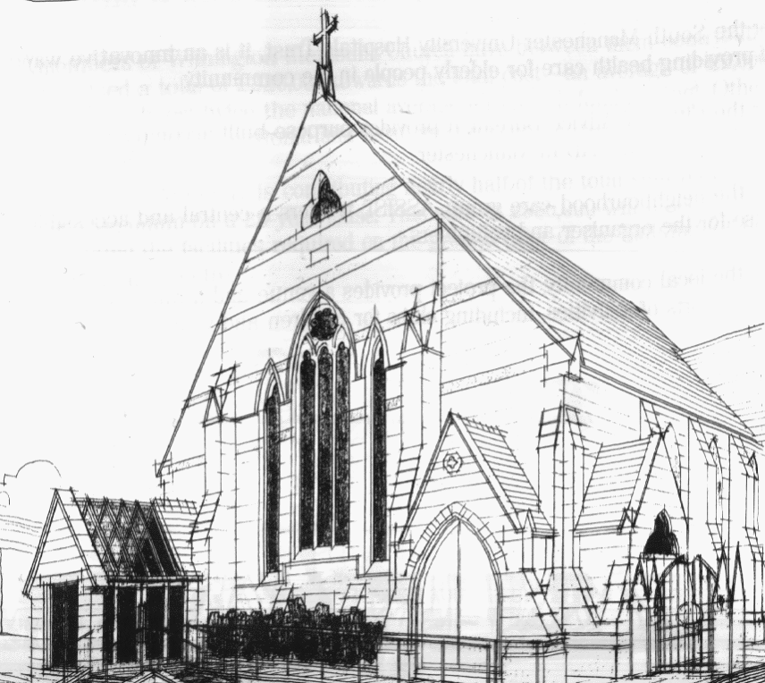
WITHINGTON METHODIST CHURCH
439 Wilmslow Road, Withington, Manchester M20 4AN
Telephone – 0161 445 0804
Minister – Revd. Dr. Caroline Wickens
E-mail – office@withingtonmethodistchurch.org (Church Office)
minister@withingtonmethodistchurch.org (Revd. Dr. Caroline Wickens)
Website – www.withingtonmethodistchurch.org

SUNDAY 13th OCTOBER 2024

HOMELESSNESS SUNDAY

PRISONS WEEK

THOUGHT FOR THE WEEK
We are all created in the image of God who came to earth to be with us and to enter into our pain and suffering as well as our joys and delight.
So, in this Prisons Week we pause to reflect on Jesus Christ’s encounters with people when he walked on earth, and his compassion, always offering hope
and the possibility of transformation even in places of suffering.

Morning Worship – 10.45am – at Levenshulme Methodist Church –

including Holy Communion – Conducted by Revd. Catharine Hughes

TODAY, Sunday 13th October, we will be joining with our friends at
Levenshulme Methodist Church (824 Stockport Road, Levenshulme, M19 3AW)
for Morning Worship at 10.45am, which will include Holy Communion,
conducted by Revd. Catharine Hughes

There will be NO Morning Worship here at Withington TODAY

Circuit Service (on Zoom) – 6.30pm – Led by Revd. Ken Stokes

The Lectionary Readings for TODAY (Sunday 13th October) are –
JOB 23 – v1 – 9 & v16 – 17 PSALM 22 – v1 – 15 HEBREWS 4 – v12 – 16
MARK 10 – v17 – 31

PRAYER CONCERNS

All those caught up in conflict around the world: Israel, Gaza, Ukraine, Sudan, Yemen, Somalia, and those facing persecution, Rosalie, Darren, Jessica, Thandiwe, Lottie, Stella, all those here who are struggling to pay their bills and facing long waits for hospital appointments, all those friends still impacted by Covid-19,

those members and friends unable to be with us,

we pray for the future plans of this church and our building partners

SUNDAY 20th OCTOBER 2024

ONE WORLD WEEK

Morning Worship – 10.45am – including Holy Communion –

Conducted by Revd. Dr. Caroline Wickens

Circuit Service (on Zoom) – 6.30pm –

Led by Revd. Dr. James Tebbutt and Revd. Dr. Caroline Wickens

The Lectionary Readings for Next Sunday (October 20th) are –
JOB 38 – v1 – 7 PSALM 104 – v1 – 9, v24 & v35c HEBREWS 5 – v1 – 10
MARK 10 – v35 – 45

CIRCUIT SERVICE (ZOOM JOINING DETAILS)

https://zoom.us/j/92204599032?pwd=Tzg0SU9xcVZEZFNQK0FnYnNKWjlUQT09

Meeting ID: 922 0459 9032 Passcode: 1901

CHURCH ACTIVITIES

Wednesdays @ Withington –

10.45am – Meet the Minister


Book Club
Next Meeting – Monday 14th October at 7.30pm
This month we are reading ‘Q and A’ by Vikas Swarup
New members always welcome!

Bible Study –

A warm invitation is extended to all to our autumn Bible Study series,

which continues on Wednesday 23rd October at 12.00noon in the Church Lounge.

We are reading parts of Genesis together – it’s the Bible month book for 2024.

This time we will be looking at – A divine / human partnership – Genesis 12 – v1 – 20.

Many thanks.

Manchester Gospel Choir Concert – Saturday 23rd November –
We are delighted to welcome back the Manchester Gospel Choir and Friends to perform a concert here again at Withington Methodist Church this November.
Please note in your diaries that this concert will take place here on
Saturday 23rd November at 7.00pm,
(and not on Saturday 2nd November as previously advertised).
Tickets are available from the Church Office.
Admission is free, and donations will be very gratefully received on the evening for the work of the Methodist Church Monday’s Undies Appeal. Many thanks.

