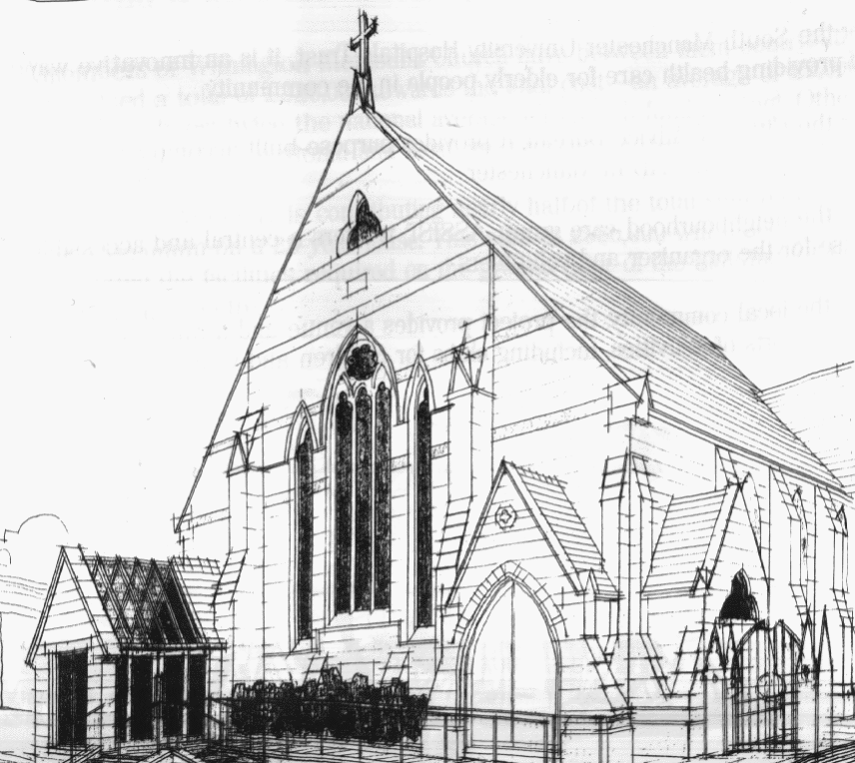
WITHINGTON METHODIST CHURCH
439 Wilmslow Road, Withington, Manchester M20 4AN
Telephone – 0161 445 0804
Minister – Revd. Dr. Caroline Wickens
E-mail – office@withingtonmethodistchurch.org (Church Office)
minister@withingtonmethodistchurch.org (Revd. Dr. Caroline Wickens)
Website – www.withingtonmethodistchurch.org

SUNDAY 6th OCTOBER 2024

THOUGHT FOR THE WEEK
Heavenly Father, my neighbour has nowhere to call home: Help me be aware.
My neighbour needs love and community: Help me be active.
My neighbour is crying out for justice:
HELP ME TO ANSWER THEIR PLEA FOR HELP. AMEN.

Morning Worship – 10.45am – Led by Dr. Adrian Curtis

Circuit Service (on Zoom) – 6.30pm – including Holy Communion –

Conducted by Revd. Sharon Read

The Lectionary Readings for TODAY (Sunday 6th October) are –
JOB 1 – v1 JOB 2 – v1 – 10 PSALM 26 HEBREWS 1 – v1 – 4
HEBREWS 2 – v5 – 12 MARK 10 – v2 – 16

PRAYER CONCERNS

All those caught up in conflict around the world: Israel, Gaza, Ukraine, Sudan, Yemen, Somalia, and those facing persecution, the family and friends of Gwendoline, Jessica, Thandiwe, Lottie, Stella, all those here who are struggling to pay their bills and facing long waits for hospital appointments, all those friends still impacted by Covid-19,

those members and friends unable to be with us,

we pray for the future plans of this church and our building partners

CHURCH ACTIVITIES

Wednesdays @ Withington –

10.45am – Meet the Minister

SUNDAY 13th OCTOBER 2024

HOMELESSNESS SUNDAY

PRISONS WEEK

Morning Worship – 10.45am – at Levenshulme Methodist Church –

including Holy Communion – Conducted by Revd. Catharine Hughes

Next Sunday, October 13th, we will be joining with our friends at
Levenshulme Methodist Church (824 Stockport Road, Levenshulme, M19 3AW)
for Morning Worship at 10.45am, which will include Holy Communion,
conducted by Revd. Catharine Hughes

There will be NO Morning Worship here at Withington next Sunday

Circuit Service (on Zoom) – 6.30pm – Led by Revd. Ken Stokes

The Lectionary Readings for Next Sunday (October 13th) are –
JOB 23 – v1 – 9 & v16 – 17 PSALM 22 – v1 – 15 HEBREWS 4 – v12 – 16
MARK 10 – v17 – 31

CIRCUIT SERVICE (ZOOM JOINING DETAILS)

https://zoom.us/j/92204599032?pwd=Tzg0SU9xcVZEZFNQK0FnYnNKWjlUQT09

Meeting ID: 922 0459 9032 Passcode: 1901

Bible Study –

A warm invitation is extended to all to our autumn Bible Study series,

which continues this coming Wednesday, October 9th at 12.00noon in the

Church Lounge.

We are reading parts of Genesis together – it’s the Bible month book for 2024.

This time we will be looking at – The promise of a new future – Genesis 9 – v8 – 17.

Many thanks.

Church Council Meeting –
Our next Church Council Meeting will take place this coming Wednesday, October 9th
at 7.00pm. Many thanks.


Book Club
Next Meeting – Monday 14th October at 7.30pm
This month we are reading ‘Q and A’ by Vikas Swarup
New members always welcome!

