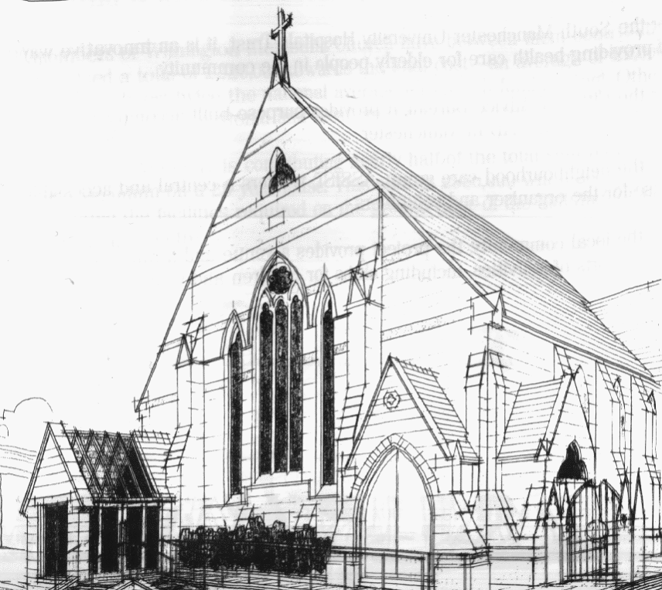
WITHINGTON METHODIST CHURCH
439 Wilmslow Road, Withington, Manchester M20 4AN
Telephone – 0161 445 0804
Minister – Revd. Dr. Caroline Wickens
E-mail – office@withingtonmethodistchurch.org (Church Office)
minister@withingtonmethodistchurch.org (Revd. Dr. Caroline Wickens)
Website – www.withingtonmethodistchurch.org

SUNDAY 15th SEPTEMBER 2024

THOUGHT FOR THE WEEK
We are in the middle of Fairtrade Fortnight.
Though we no longer have a Fair Trade stall on Sunday mornings,
we need to remember how much difference fair trade makes to producers
across the world who receive a fair income for their produce.
‘Be the Change’ is this year’s headline –
pick up Fair Trade products and speak up for Fair Trade.

Morning Worship – 10.45am – including Holy Communion –

Conducted by Revd. Dr. Caroline Wickens

Circuit Service (on Zoom) – 6.30pm – Led by Revd. Sharon Read

The Lectionary Readings for TODAY (Sunday 15th September) are –
PROVERBS 1 – v20 – 33 PSALM 19 JAMES 3 – v1 – 12 MARK 8 – v27 – 38

PRAYER CONCERNS

All those caught up in conflict around the world: Israel, Gaza, Ukraine, Sudan, Yemen, Somalia, and those facing persecution, the family and friends of Gwendoline, Jessica, Thandiwe, Lottie, Stella, all those here who are struggling to pay their bills and facing long waits for hospital appointments, all those friends still impacted by Covid-19,

those members and friends unable to be with us,

we pray for the future plans of this church and our building partners

CHURCH ACTIVITIES

Wednesdays @ Withington –

10.45am – Meet the Minister

SUNDAY 22nd SEPTEMBER 2024

PEACE SUNDAY

Morning Worship – 10.45am – Led by Mr. Nick Palfreyman

Circuit Service (on Zoom) – 6.30pm – Led by Revd. Catharine Hughes

The Lectionary Readings for Next Sunday (September 22nd) are –
PROVERBS 31 – v10 – 31 PSALM 1 JAMES 3 – v13 – JAMES 4 – v3 & v7 – 8a
MARK 9 – v30 – 37

CIRCUIT SERVICE (ZOOM JOINING DETAILS)

https://zoom.us/j/92204599032?pwd=Tzg0SU9xcVZEZFNQK0FnYnNKWjlUQT09

Meeting ID: 922 0459 9032 Passcode: 1901


Book Club
Next Meeting – Monday 16th September at 7.30pm
This month we are reading ‘Brooklyn’ by Colm Toibin
New members always welcome!

Withington Pride – Saturday 21st September –
Withington Pride is being held on Saturday 21st September and all are welcome to join the festivities and represent our open and welcoming church.
There will be a parade starting at Withington Baths at 1:30pm which will end outside WMC. We will then be holding a Parade Service in the church at 2.00pm followed by refreshments – please see details below –
All are welcome to join us for our PRIDE service
- at *Withington Methodist Church* (where the parade finishes!)
- at *2.00pm* (when the parade finishes!)
It will last around 30 minutes with tea, coffee and cake afterwards.
We will take time out to remember God's love for their creation, and to pray for a world of justice where everyone is loved for who they are.
It will be quiet. It will be reflective. And then there will be refreshments.

There are various community events throughout the day around Withington including a Ceilidh at 5.00pm – 7.00pm, which is being held at Withington Methodist Church.
Those who are not LGBT+ are welcome as allies and it would be brilliant to show our support and that we are a part of the Withington community.
We would also appreciate anyone able to help with the refreshments after the service.
Many thanks.

Bible Study –

A warm invitation is extended to all to our autumn Bible Study series,

which continues on Wednesday 25th September at 12.00noon.

We are reading parts of Genesis together – it’s the Bible month book for 2024.

This time we will be looking at – The day it all went wrong – Genesis 3 – v1 – 24.

Many thanks.

Harvest Festival and Bread Church –
Our Harvest Festival Service will be held on Sunday 29th September at 10.45am,
and will incorporate the baking of Bread, giving people the opportunity to experience
Bread Church if they haven’t had the opportunity to attend one of these services before.
As usual we will be gratefully accepting donations of non-perishable food to support our
local food banks and charities. Many thanks.

