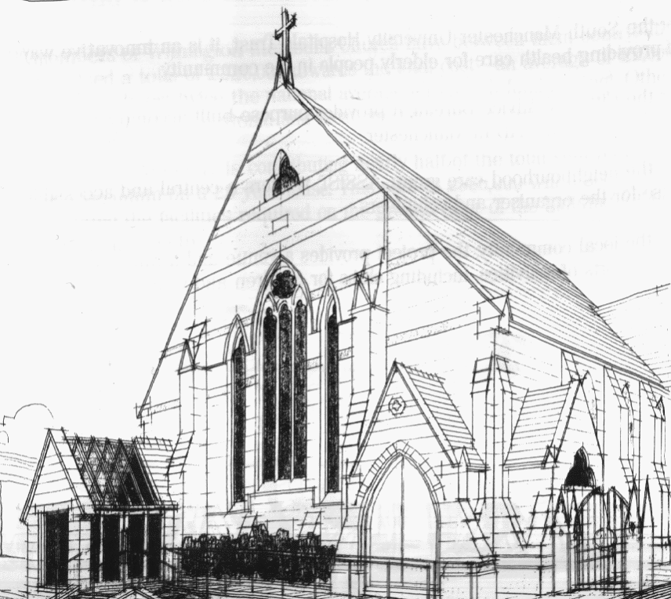
WITHINGTON METHODIST CHURCH
439 Wilmslow Road, Withington, Manchester M20 4AN
Telephone – 0161 445 0804
Minister – Revd. Dr. Caroline Wickens
E-mail – office@withingtonmethodistchurch.org (Church Office)
minister@withingtonmethodistchurch.org (Revd. Dr. Caroline Wickens)
Website – www.withingtonmethodistchurch.org

SUNDAY 22nd SEPTEMBER 2024
PEACE SUNDAY

THOUGHT FOR THE WEEK
The UN International Day of Peace falls on 21 September.
In a world of chaos and violence we so much need to pray and work towards peace. We are invited to remember the prophet Micah’s great image of peace:
each one relaxing under their own vine and their own fig tree (Micah 4:4).
Where do we need to build peace in our own lives?

Morning Worship – 10.45am – Led by Mr. Nick Palfreyman

Circuit Service (on Zoom) – 6.30pm – Led by Revd. Catharine Hughes

The Lectionary Readings for TODAY (Sunday 22nd September) are –
PROVERBS 31 – v10 – 31 PSALM 1 JAMES 3 – v13 – JAMES 4 – v3 & v7 – 8a
MARK 9 – v30 – 37

PRAYER CONCERNS

All those caught up in conflict around the world: Israel, Gaza, Ukraine, Sudan, Yemen, Somalia, and those facing persecution, the family and friends of Gwendoline, Jessica, Thandiwe, Lottie, Stella, all those here who are struggling to pay their bills and facing long waits for hospital appointments, all those friends still impacted by Covid-19,

those members and friends unable to be with us,

we pray for the future plans of this church and our building partners

CHURCH ACTIVITIES

Wednesdays @ Withington –

10.45am – Meet the Minister

SUNDAY 29th SEPTEMBER 2024

Morning Worship – Harvest Festival Service – 10.45am – including the baking of Bread – Led by Revd. Dr. Caroline Wickens

Circuit Service (on Zoom) – 6.30pm – Led by Revd. Dr. Caroline Wickens

The Lectionary Readings for Next Sunday (September 29th) are –
ESTHER 7 – v1 – 6 & V9 – 10 ESTHER 9 – v20 – 22 PSALM 124 JAMES 5 – v13 – 20 MARK 9 – v38 – 50

CIRCUIT SERVICE (ZOOM JOINING DETAILS)

https://zoom.us/j/92204599032?pwd=Tzg0SU9xcVZEZFNQK0FnYnNKWjlUQT09

Meeting ID: 922 0459 9032 Passcode: 1901

Bible Study –

A warm invitation is extended to all to our autumn Bible Study series,

which continues this coming Wednesday, September 25th at 12.00noon.

We are reading parts of Genesis together – it’s the Bible month book for 2024.

This time we will be looking at – The day it all went wrong – Genesis 3 – v1 – 24.

Many thanks.

Management Team Meeting –
Our next Management Team Meeting will take place here at church
this coming Wednesday, September 25th at 7.00pm. Thank you.

Harvest Festival and Bread Church –
Our Harvest Festival Service will be held next Sunday, September 29th at 10.45am,
and will incorporate the baking of Bread, giving people the opportunity to experience
Bread Church if they haven’t had the opportunity to attend one of these services before.
As usual we will be gratefully accepting donations of non-perishable food to support our
local food banks and charities. Many thanks.


Book Club
Next Meeting – Monday 14th October at 7.30pm
This month we are reading ‘Q and A’ by Vikas Swarup
New members always welcome!

