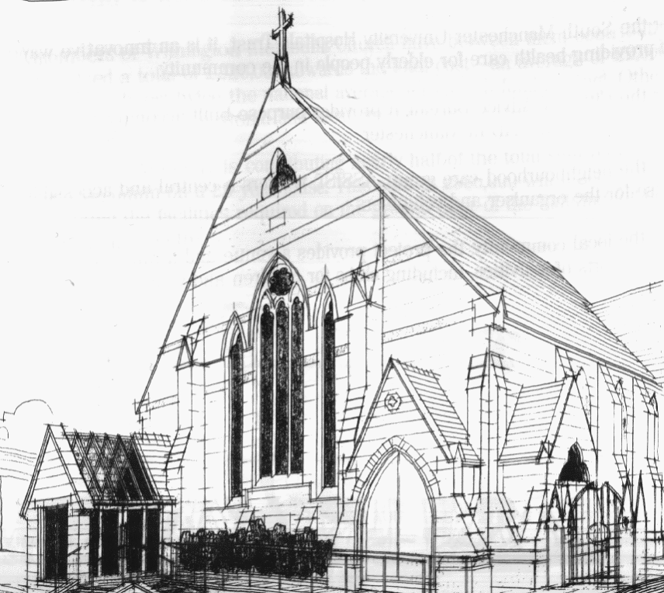
WITHINGTON METHODIST CHURCH
439 Wilmslow Road, Withington, Manchester M20 4AN
Telephone – 0161 445 0804
Minister – Revd. Dr. Caroline Wickens
E-mail – office@withingtonmethodistchurch.org (Church Office)
minister@withingtonmethodistchurch.org (Revd. Dr. Caroline Wickens)
Website – www.withingtonmethodistchurch.org

SUNDAY 20th OCTOBER 2024

ONE WORLD WEEK

THOUGHT FOR THE WEEK
God of the poor, friend of the weak,
Give us compassion, we pray;
Mend our cold hearts, let tears fall like rain.
Come, change our love from a spark to a flame
(StF 693, Beauty for brokenness)

Morning Worship – 10.45am – including Holy Communion –

Conducted by Revd. Dr. Caroline Wickens

Circuit Service (on Zoom) – 6.30pm –

Led by Revd. Dr. James Tebbutt and Revd. Dr. Caroline Wickens

The Lectionary Readings for TODAY (Sunday 20th October) are –
JOB 38 – v1 – 7 PSALM 104 – v1 – 9, v24 & v35c HEBREWS 5 – v1 – 10
MARK 10 – v35 – 45

PRAYER CONCERNS

All those caught up in conflict around the world: Israel, Gaza, Ukraine, Sudan, Yemen, Somalia, and those facing persecution, Hazel, everyone in Souchay Court, Rosalie, Darren, Jessica, Thandiwe, Lottie, Stella, all those here who are struggling to pay their bills and facing long waits for hospital appointments, all those friends still impacted by Covid-19,

those members and friends unable to be with us,

we pray for the future plans of this church and our building partners

SUNDAY 27th OCTOBER 2024

BIBLE SUNDAY

Morning Worship – 10.45am – Led by Mr. Phil Davis

Circuit Service (on Zoom) – 6.30pm – Led by Revd. Paul Welch

The Lectionary Readings for Next Sunday (October 27th) are –
JOB 42 – v1 – 6 & v10 – 17 PSALM 34 – v1 – 8 HEBREWS 7 – v23 – 28
MARK 10 – v46 - 52

CIRCUIT SERVICE (ZOOM JOINING DETAILS) (OCTOBER 27th)

https://zoom.us/j/92204599032?pwd=Tzg0SU9xcVZEZFNQK0FnYnNKWjlUQT09

Meeting ID: 922 0459 9032 Passcode: 1901

Circuit Service on Zoom –

This evening, Sunday 20th October, all are warmly invited to join our Circuit Service on Zoom at 6.30pm, when we will be delighted to welcome our new Chair of District,

Revd. Dr. James Tebbutt to preach.

Please note the joining details for the Zoom call for tonight are –

https://zoom.us/j/3983131639?pwd=czVWQnlNclJyTDhLbTdwM1hlcW9YQT09

Many thanks.

CHURCH ACTIVITIES

Wednesdays @ Withington –

10.45am – Meet the Minister

Bible Study –

A warm invitation is extended to all to our autumn Bible Study series,

which continues this coming Wednesday, October 23rd at 12.00noon

in the Church Lounge.

We are reading parts of Genesis together – it’s the Bible month book for 2024.

This time we will be looking at – A divine / human partnership – Genesis 12 – v1 – 20.

Many thanks.


Book Club
Next Meeting – Monday 11th November at 7.30pm
This month we are reading ‘The Talented Mr. Ripley’ by Patricia Highsmith
New members always welcome!

Manchester Gospel Choir Concert – Saturday 23rd November –
We are delighted to welcome back the Manchester Gospel Choir and Friends to perform a concert here again at Withington Methodist Church this November.
Please note in your diaries that this concert will take place here on
Saturday 23rd November at 7.00pm,
(and not on Saturday 2nd November as previously advertised).
Tickets are available from the Church Office, or please call 0161-445-0804 or 07773 015882.
Admission is free, and donations will be very gratefully received on the evening for the work of the Methodist Church Monday’s Undies Appeal. Many thanks.

