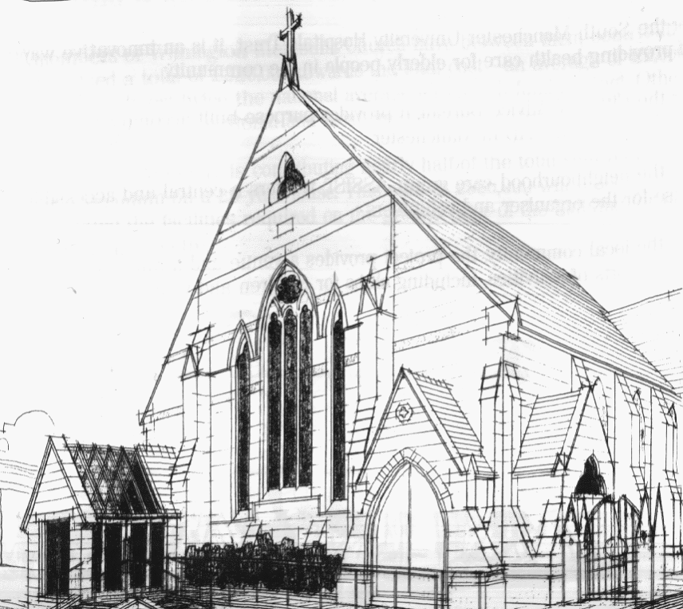
WITHINGTON METHODIST CHURCH
439 Wilmslow Road, Withington, Manchester M20 4AN
Telephone – 0161 445 0804
Minister – Revd. Dr. Caroline Wickens
E-mail – office@withingtonmethodistchurch.org (Church Office)
minister@withingtonmethodistchurch.org (Revd. Dr. Caroline Wickens)
Website – www.withingtonmethodistchurch.org

SUNDAY 29th SEPTEMBER 2024

THOUGHT FOR THE WEEK
A good harvest has led to joyful celebration for generations.
The food to keep us going through the winter is there, in barn and store.
This year the harvest is patchier. Unusual weather has created problems
across the world, with drought and flooding leading to famine for some.
As we celebrate our harvest festival, we must not take it for granted that
we have enough to eat or forget those who can’t access the food they need.

Morning Worship – 10.45am – Harvest Festival Service –

including the baking of Scones – Led by Revd. Dr. Caroline Wickens

We extend an especially warm welcome today to our friends from
Levenshulme Methodist Church, who are joining us for Morning Worship

Followed by Lunch – please see notice

Circuit Service (on Zoom) – 6.30pm – Led by Revd. Dr. Caroline Wickens

The Lectionary Readings for TODAY (Sunday 29th September) are –
ESTHER 7 – v1 – 6 & V9 – 10 ESTHER 9 – v20 – 22 PSALM 124 JAMES 5 – v13 – 20 MARK 9 – v38 – 50

PRAYER CONCERNS

All those caught up in conflict around the world: Israel, Gaza, Ukraine, Sudan, Yemen, Somalia, and those facing persecution, the family and friends of Gwendoline, Jessica, Thandiwe, Lottie, Stella, all those here who are struggling to pay their bills and facing long waits for hospital appointments, all those friends still impacted by Covid-19,

those members and friends unable to be with us,

we pray for the future plans of this church and our building partners

CHURCH ACTIVITIES

Wednesdays @ Withington –

10.45am – Meet the Minister

SUNDAY 6th OCTOBER 2024

Morning Worship – 10.45am – Led by Dr. Adrian Curtis

Circuit Service (on Zoom) – 6.30pm – including Holy Communion –

Conducted by Revd. Sharon Read

The Lectionary Readings for Next Sunday (October 6th) are –
JOB 1 – v1 JOB 2 – v1 – 10 PSALM 26 HEBREWS 1 – v1 – 4
HEBREWS 2 – v5 – 12 MARK 10 – v2 – 16

CIRCUIT SERVICE (ZOOM JOINING DETAILS)

https://zoom.us/j/92204599032?pwd=Tzg0SU9xcVZEZFNQK0FnYnNKWjlUQT09

Meeting ID: 922 0459 9032 Passcode: 1901

Harvest Festival and Bread Church –
Our Harvest Festival Service will be held TODAY at 10.45am,
and will incorporate the baking of savoury scones, giving people the opportunity to experience
Bread Church if they haven’t had the opportunity to attend one of these services before.
Following the service, everyone is warmly invited to stay and share a Lunch of the scones and soup together.
Donations of tinned foods, toiletries or monetary offerings will be very gratefully received for the work of the Withington and Fallowfield Foodbank. Many thanks.

Bible Study –

A warm invitation is extended to all to our autumn Bible Study series,

which continues on Wednesday 9th October at 12.00noon in the Church Lounge.

We are reading parts of Genesis together – it’s the Bible month book for 2024.

This time we will be looking at – The promise of a new future – Genesis 9 – v8 – 17.

Many thanks.


Book Club
Next Meeting – Monday 14th October at 7.30pm
This month we are reading ‘Q and A’ by Vikas Swarup
New members always welcome!

